Celebrating 125 Years of Lisle Benedictine Sisters of Sacred Heart Monastery

Prayer of Gratitude

“Kind and merciful God, we honor the Benedictine Sisters of Sacred Heart Monastery and rejoice with them as they celebrate their 125th anniversary.

You, O Lord, have sustained them by your grace and love.

We are blessed by their presence in our lives and the witness of their religious profession: stability, fidelity to the monastic life and obedience.

Today, we praise you for their openness through the years to respond to the diverse needs of the Church.

O Loving God, through the intercession of Saints Benedict and Scholastica, we ask your blessing on the Sisters, in the name of the Father, the Son and the Holy Spirit.

Amen.”

February 2, 2020

From February 2, 2020 to February 2, 2021, we celebrated and gave, and continue to give, thanks on the occasion of our 125th anniversary.

Each day of the celebration year, we shared our story with you – on our website, Facebook and Instagram. Daily, we featured a short description of one of our sisters near or on the day of her death if deceased, or on her birthday if living. When not featuring a Sister, we shared glimpses of our history or features of our lives that are important to us.

Note: These posts were extended through February 14, 2021 so we could relive and share photos from our February 2, 2020 Mass and celebration. This full history of our community can still be viewed on our website www.shmlisle.org and on our Facebook page Benedictine Sisters of the Sacred Heart https://www.facebook.com/shmlisle

Our first post:

Day 1: February 2, 2020

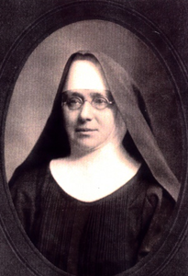
Intro: Mother Nepomucene Jaeger
It was February 2, 1895 that Mother Nepomucene Jaeger, arrived in Chicago from St. Mary’s Convent in St. Joseph, Pennsylvania. Sisters Mary Zita Matous and Sister Mary Benedicta Hruby from St Scholastica’s convent in Chicago joined her and together with Abbot Nepomucene Jaeger celebrated their first Mass and thus began our foundation.

Our 125th Anniversary Celebration
This panoramic view of the opening of our 125th anniversary celebration on February 2, 2020 gives us a chance to deliver a panoramic “thank you” to all those who have made the daily historical events published this year happen.
This gratitude includes, but is not limited to, those who did the research, took photos, wrote the script, did the editing and publishing on social media and you the viewer and commenter – thank you for sharing our journey!
We are grateful to Bill Buchelt of Elan Studio whose complimentary photography was featured on January 31 and will be featured until February 14.
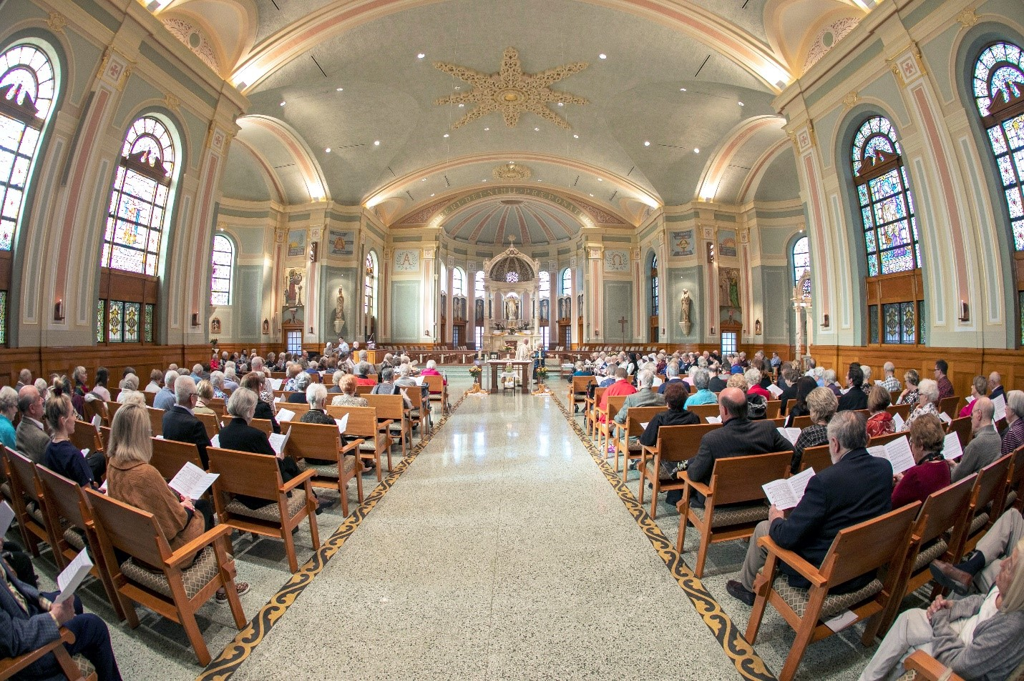

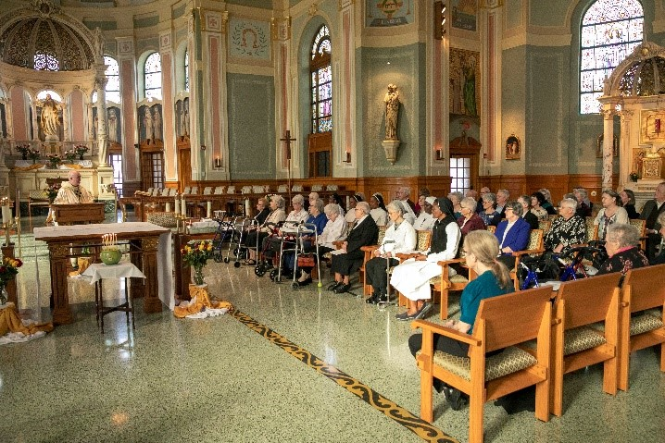
Our Chaplain, Father Becket, Giving the Homily for our Celebration (2/2/2020)
Father Becket is talking here directly to the Sisters on their 125th Anniversary Mass. He is saying that through their history, they ministered to others in various venues and now it would be time to take care of each other. This was a poignant moment for the Sisters to reflect on the beauty of their service to the people of God in the past, and now to look forward to their ministry of building closer ties of love and service to each other in community.

Gifts to celebrate our 125 years!

Our first jubilee gift to ourselves and those who enter our chapel was a stained glass window installed above our reliquary just outside our Chapel entrance.
The blessing took place on June 19, 2020 - the Feast of the Sacred Heart of Jesus.

“Good and gracious God, we come before you as a grateful Benedictine Community on this, the feast of the Sacred Heart of Jesus, after whom we are named, in the year 2020, on the occasion of our 125th anniversary.

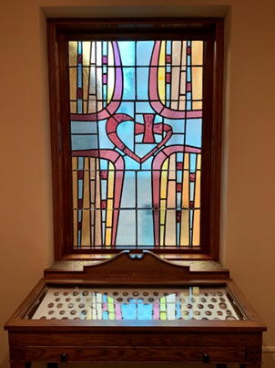
We stand before you admiring a stained glass window whose artwork includes that of Sister Emmanuel Pieper, a Benedictine of St. Walburg in Kentucky. This stained glass window was crafted by Marie Tatina, who in her history, has created and made the windows in our Monastic choir, as well as re-leaded the stained glass windows in our chapel.

We are grateful for the gifts of time and talent shared by Sister Emmanuel and Marie Tatina as well as for our maintenance employee, Eric Shumaker, who has carefully installed the window and varnished the frame.

As we bless + this window, we ask that those who pass by it on their way to Sacred Heart Monastery Chapel would find inspiration from the Monastery’s Logo, the heart signed with a cross. May the cross remind us that through the cross Jesus gifted us with our salvation.

We ask all this in the Name of our Loving Creator God, Jesus our Brother and Redeemer, and the Holy Spirit, our Gift-Giver and Sanctifier. Amen.”

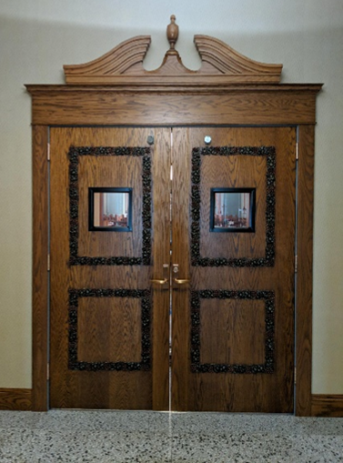
We blessed our newly installed chapel doors on September 17, 2020 - the feast of St. Hildegarde of Bingen, who, among her many gifts was known for putting her visions into spiritual thoughts and art. Suburban Door Check & Lock Service, Inc. ordered and installed these beautiful fire-rated doors, and John Caretti & Company repaired the terrazzo at the door opening. Mike Holtz of Der Holtzmacher designed the doors, stained and sealed the doors, and created and installed the grape and leaf design.

We prayed:
“Welcoming God, we open this Chapel Door as a sign of the warmth of our Benedictine and Your hospitality. As people come and go, may they experience the blessedness of Your gracious presence with us. Gracious God, may we be as open to others as You have welcomed us into Your heart.”

Another blessing to celebrate 125 years!

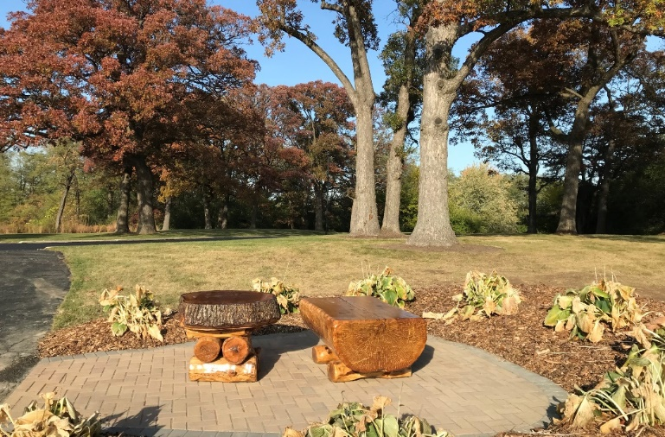
Kevin Gray, nephew of Sister Carolyn Sieg, OSB and owner of Undercutter Tree Services, combined his scientific knowledge of trees, carpentry and artistic design skills to preserve and transform a tree from our grounds into a beautiful memorial gift for our 125th anniversary. Removing the tree three years ago, he meticulously counted rings to determine that the red oak had graced our campus since 1834 - the oldest tree on the grounds.

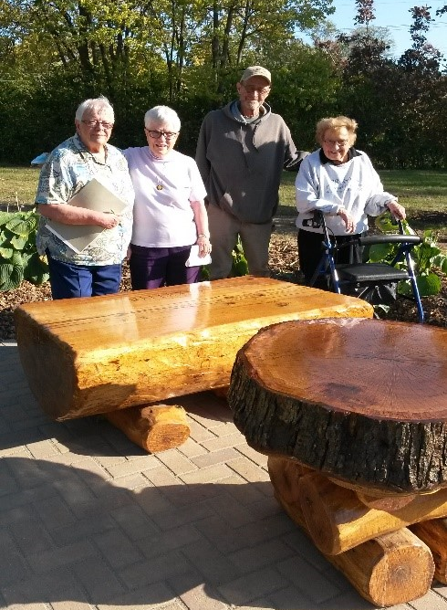
Despite health challenges, Kevin was inspired to create a memorial on the holy ground where the tree once grew. He constructed the table from a cross slice of the tree, leaving the bark encasing its natural shape of a heart. This heart makes its appearance within the tree trunk shortly before the Sisters purchased the land in 1905. Logs reclaimed from the tree were also formed and sculpted into a bench. While devoting himself to this project, Kevin’s artistic eye also discerned angel wings (signifying God’s protection) and a Tao cross in the wood.

Our Sisters are thrilled and grateful to Kevin for this magnificent treasure he so thoughtfully created for us!

(L-R) S. Jo Anne Form, S. Mary Bratrsovsky, Kevin Gray, S. Carolyn Sieg

The creation and blessing of St. Benedict statue

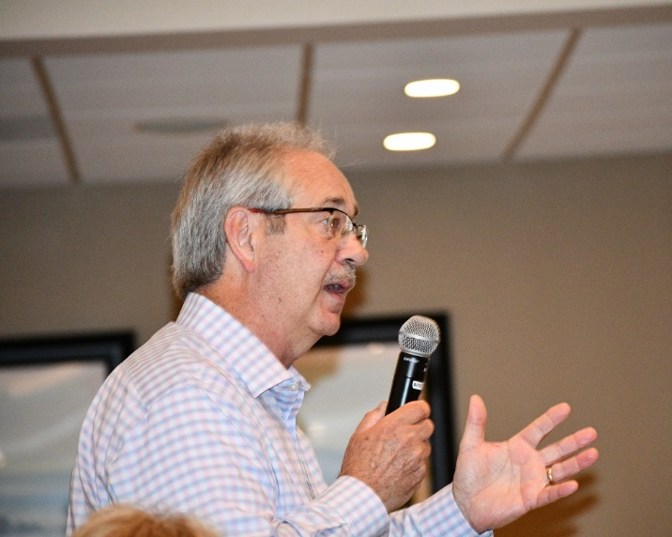
On July 11, 2021 - the Feast of St. Benedict, the statue of St. Benedict that the Sisters gifted to Villa St. Benedict was blessed.
Heaven provided its own blessing that day in the form of rain.
Larry Johnson, who created this magnificent sculpture, provided a most interesting presentation to the Sisters, residents and employees on the process, from the statue’s inception to its installation on September 23, 2020. He elaborated on the meaning of the statue and the process of its fabrication.

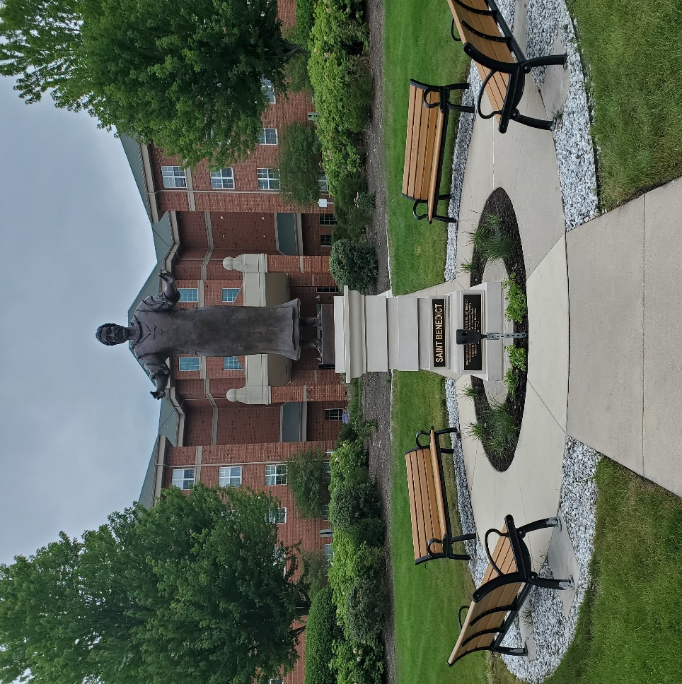
“Good and gracious God, we come before you as grateful Benedictine Sisters, Villa St Benedict Residents, employees and friends on this feast of our patron and founder St. Benedict, July 11, 2021.

It was the desire of the Benedictine Sisters to gift this sculpture to Villa St. Benedict during their 125th anniversary and thus we engaged Larry Johnson to fabricate this sculpture.

As we bless this statue + we ask that those who pass by it on the grounds, would find inspiration from the man Benedict, who modeled and lived an example of being enveloped in Scripture and prayer. We pray that each of us would continue to incorporate in our lives the Villa St. Benedict core values of stewardship, hospitality, respect and justice.

We ask all this in the Name of our Loving Creator God, Jesus our Brother and Redeemer and the Holy Spirit our Gift-Giver and Sanctifier, Amen.”

A Community Project

As Sister Carolyn Sieg was reviewing the book Pleading, Cursing, Praising: Conversing With God Through the Psalms, authored by Sister Irene Nowell, OSB, she was intrigued by Sister Irene’s statement that Psalm 150 is an unfinished psalm. The Psalm praises the Lord and says where and how to praise God, but does not say why. Sister Irene then encouraged her readers to write their own psalm with personal reasons for God’s praise as a continuation of Psalm 150.

Sister Carolyn saw this as an opportunity to have the community participate in telling their story of praise in gratitude for our Benedictine lives, to remember our 125th Anniversary. Every Sister had a chance to participate. Sister Carolyn asked Sisters Jo Anne Form and Christine Kouba to join her in compiling similar thoughts of the Sisters to form a final version of our own Psalm 150.

Psalm 150
Composed by the Lisle Benedictine Sisters
for their 125th Anniversary

Praise the Lord for the founders of this community who set the pace and fulfilled God’s plan. They had the courage to remain faithful to their monastic profession even in the midst of hardship and uncertainty, always trusting in God’s faithful presence with them.

Praise the Lord for the generations of Sisters before us who planned well for the future which was always on their mind. Now we are the beneficiaries of what they sacrificed in order to provide for us.

Praise the Lord for the Council Planning Team who are stewarding our resources. The quality time, effort and involvement with outside experts have comforted the community with peace and hope for the continuation of our Benedictine Charism in the future.

Praise the Lord for the Monks of St. Procopius Abbey who from the beginning of the poverty-stricken years of our founding, upheld our community with their brotherly encouragement and financial support, and through these 125 years have maintained a brother/sister relationship with us similar to that of Saints Benedict and Scholastica.

Praise the Lord for all our benefactors: our families, friends, volunteers, as well as our Villa St. Benedict Residents whose friendship and financial support are a blessing to us.

Praise the Lord for the ongoing developments of Vatican II: in the Liturgy, in promoting justice issues related to the role of women and in the call to all religious communities to be a discerning presence in our alienated world.

Praise the Lord for the great rewards of living in our Benedictine community as we strive to live in fidelity to prayer and work with joy and hope as we share our time and talents with each other.

Praise the Lord for the daily rhythm of the Liturgy of the Hours. How meaningful these precious, sacred times have become as we chant the Divine Office, uniting our hearts and minds with the universal church on earth and in heaven.

Praise the Lord for our place of worship, our chapel. Its adorned environment has surrounded us with the inspiration, peace and beauty that is needed to be aware of the magnificent presence of God and to focus on Jesus in the Eucharist.

Praise God for our chaplain whose ministry involves administering the sacraments, giving personal, pastoral care to each of us and for his relevant words of wisdom as he challenges us to become witnesses of the Gospel.

Praise the Lord for our devoted families, employees and volunteers. Their vital service and care extends and revitalizes our worthy Benedictine charism.

Praise the Lord for our beautiful grounds as we enjoy nature walks in the changing seasons and see God’s beauty all around us.

Praise the Lord for the UNKNOWN challenges of our preferred future while in retrospect, we know that God is already in that future with us. ALLELUIA!

Praise the Lord for our involvement with our international students with whom we share our Benedictine life.

Praise God for the example of our residents who are loyal and grateful supporters of our ministries. By their presence and friendship they keep us energized in our hospitality.

Praise the Lord for our monastic life which requires us to stay at the table, facing the tears, joys and sorrows of our daily lives without looking for greener pastures but persevering on our journey toward our desired home.

Praise the Lord for our community as we continue to be a support to one another on this monastic journey as God’s faithful, joyful, hopeful followers of Jesus in our transformation stage.

Praise the Lord for the success of Villa St. Benedict as our corporate ministry, for Benedictine (formerly BHS) from Duluth who co-sponsor Villa St. Benedict and for the Duluth Benedictine Sisters who remain the spiritual advisors promoting the core values of hospitability, respect, stewardship and justice: hallmarks for the compassionate care the Sisters advocate.

Gratitude statement from the International Sisters to the Sisters of Sacred Heart Monastery:
Praise the Lord for the Benedictine Sisters of Sacred Heart Monastery who have welcomed us, as students, to live our Benedictine life with them. The Sisters not only provide us with food and shelter and other necessities but help us with our studies. How grateful we are to live with them in this foreign country and yet feel at home here in the USA.

